**UML Diagrams(UNIFIED MODELING LANGUAGE)**

* The unified modeling language allows the software engineer to express an analysis model using the modeling notation that is governed by a set of syntactic semantic.
* A UML system is represented using five different views that describe the system from distinctly different perspective. Each view is defined by a set of diagram, which is as follows.
* **User Model View** 
  + This view represents the system from the users perspective.
  + The analysis representation describes a usage scenario from the end-users perspective.
* **Structural model view** 
  + In this model the data and functionality are arrived from inside the system.
  + This model view models the static structures.
* **Behavioral Model View** 
  + It represents the dynamic of behavioral as parts of the system, depicting the interactions of collection between various structural elements described in the user model and structural model view.
* **Implementation Model View** 
  + In this the structural and behavioral as parts of the system are represented as they are to be built.
* **Environmental Model View** 
  + In this the structural and behavioral aspects of the environment in which the system is to be implemented are represented.

UML is specifically constructed through two different domains they are

* UML Analysis modeling, which focuses on the user model and structural model views of the system.
* UML design modeling, which focuses on the behavioral modeling, implementation modeling and environmental model views.

**USE-CASE DIAGRAMS:**

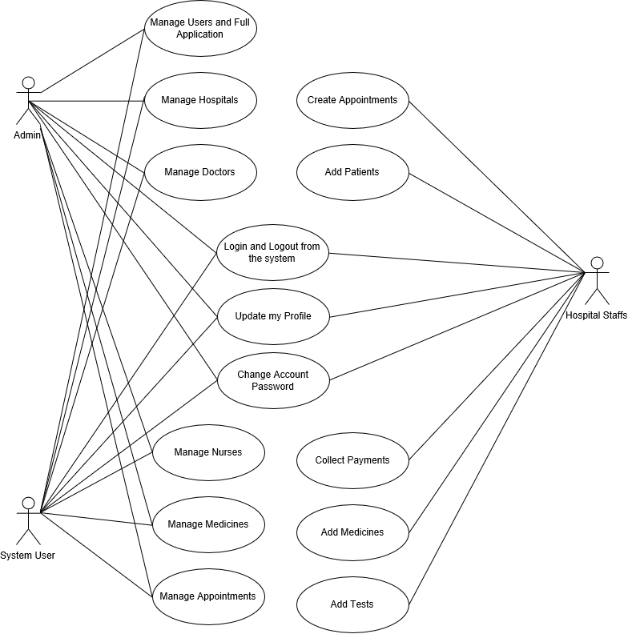

**CLASS DIAGRAMS:**

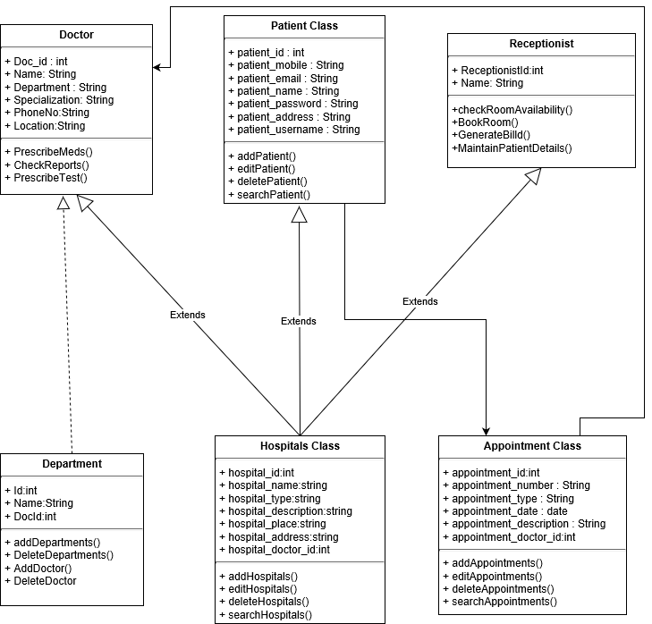

**SEQUENCE DIAGRAMS:** LOGIN SYSTEM SEQUENCE

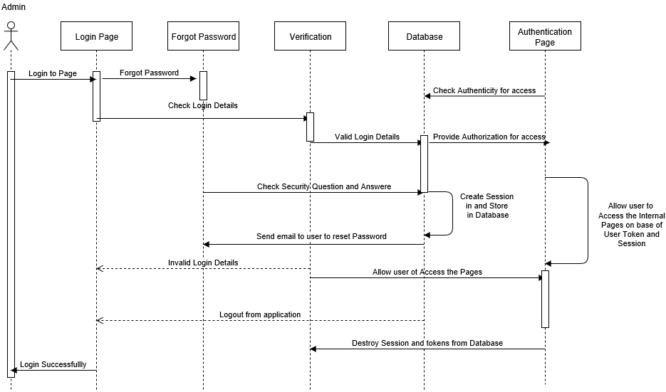

HOSPITAL SYSTEM SEQUENCE

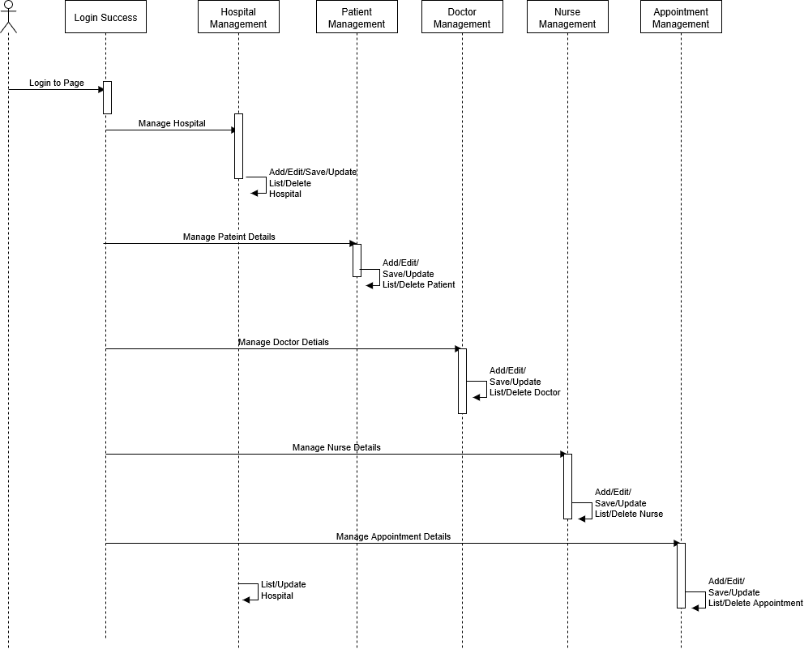

**ACTIVITY DIAGRAM:** LOGIN SYSTEM ACTIVITY

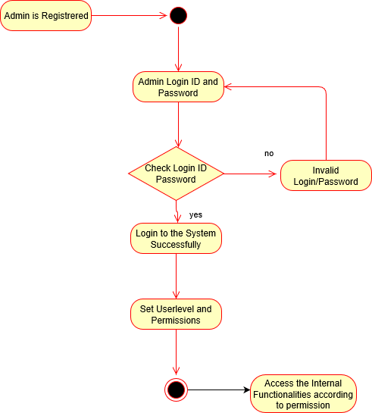

HOSPITAL SYSTEM ACTIVITY

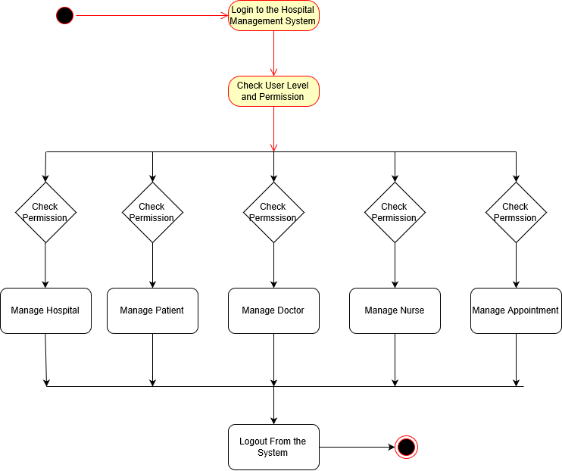

**COLLABORATION DIAGRAM:**

LOGIN SYSTEM COLLABORATION

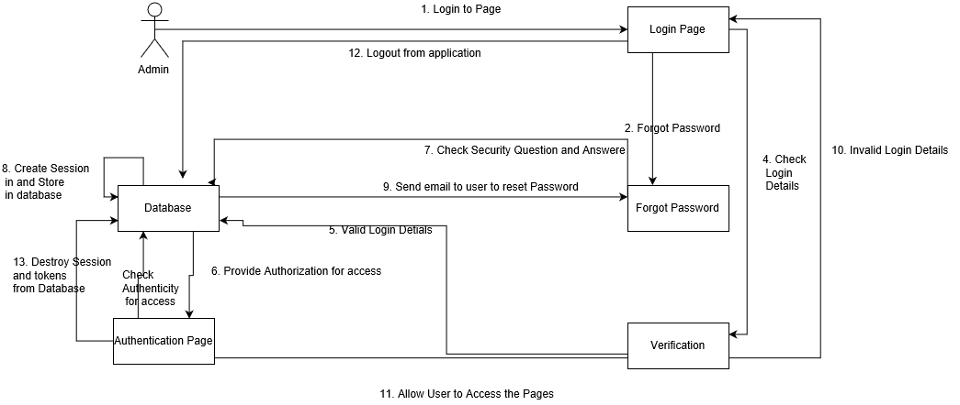

HOSPITAL SYSTEM COLLABORATION

